

High Level Scope Document – Closed Loop Digital Wallet

|  |  |
| --- | --- |
| **Client Name** | Al Ansari |
| **Project Name** | Closed Loop Digital Wallet – Transaction Processing |
| **Request ID** | NIPMO-51834 |
| **Issue date** | 6-Feb-2024 |
| **Version** | 1.0 |
| **Solution Design Manager** | Amit Gaud |
| **Relationship Manager** | Sami |

**DOCUMENT APPROVAL**

**Version History**

|  |  |  |  |
| --- | --- | --- | --- |
| **Version #** | **Dated** | **Updated by** | **Change** |
| 1.0 | 06-Feb-2024 | NI Solution Design | Draft version |
|  |  |  |  |
|  |  |  |  |
|  |  |  |  |
|  |  |  |  |

**NI Representative**

|  |  |  |
| --- | --- | --- |
| **Name** | **Position / Title** | **Signoff Requirement** |
|  |  | Review |
|  |  | Review |
|  |  | Review |

**Al Ansari Representatives**

|  |  |  |
| --- | --- | --- |
| **Name** | **Position / Title** | **Signoff** |
|  |  |  |
|  |  |  |
|  |  |  |

Table of Contents

1 Requirement 5

2 Glossary of Terms 5

3 High level Scope 5

4 Solution Overview 6

4.1 **Architecture** 6

4.2 **Transaction Process** 6

4.2.1 **Stand In Process** 6

4.2.2 **Transaction mapping** 6

4.2.3 **Customer communication** 7

4.3 **Wallet services** 7

4.3.1 **Wallet Inquiry** 7

4.3.2 **Account to Account Transfer –** (WPS Payroll to SVA wallet Transfer only) 8

4.3.3 **Wallet Top-up Via bulk Payment or top-up file** 9

4.3.4 **Wallet Top-up via Cash-in** 10

4.3.5 **Peer to Peer (P to P) Fund transfer** 10

4.3.6 **Peer to Non-Ni Merchant (QR Based)** 12

4.3.7 **Remittance** 13

4.3.8 **Bill Payment** 15

4.3.9 **P to M – N-Genius POS or N-Genius Ecomm (In-Progress at NI)** 16

4.4 **Transaction Posting/Clearing** 17

4.5 **Wallet Limiters** 17

4.6 **Transaction Details** 18

4.7 **Statement Generation** 18

4.8 **AML and Fraud Indicators** 18

4.9 **Fees and Service** 19

4.10 **Operational service** 19

4.10.1 **Chargeback & dispute management** 19

4.10.2 **Settlement** 19

5 Key Assumptions/Solution Considerations 19

6 Out of Scope 20

7 Queries/Outstanding points 20

8 Appendix 20

# Requirement

Al Ansari intends to introduce a closed loop wallet processing for their customers.

# Glossary of Terms

|  |  |  |
| --- | --- | --- |
| **Term** | **Acronym** | **Definition** |
| Network International | NI | Third Party service provider for Issuing |
| Al Ansari | Al Ansari | Wallet Provider |
| Card Management System | CMS | Way4 CMS |
| Transaction Switch | Switch | Base24 Switch |
| Foo | Foo | Customer wallet and merchant application provider |

# High level Scope

* Financial Institution (FI) set up for Al Ansari in NI UAE platform.
* One product with closed loop processing.
* Customer mobile application development for wallet management
* Balance hosting in NI CMS
* Base24 switch interface
* Authorization and Transaction processing
* Merchant application for payment acceptance
* NI middleware integration via NI API gateway (JSON via REST APIs)
* Way4 web Portal view access to CMS screens
* Operations service –
  + Settlement
* Key management
* User management
* Standard batch interfaces and reports exchange via SFTP
* Infrastructure set up

# Solution Overview

## **Architecture**

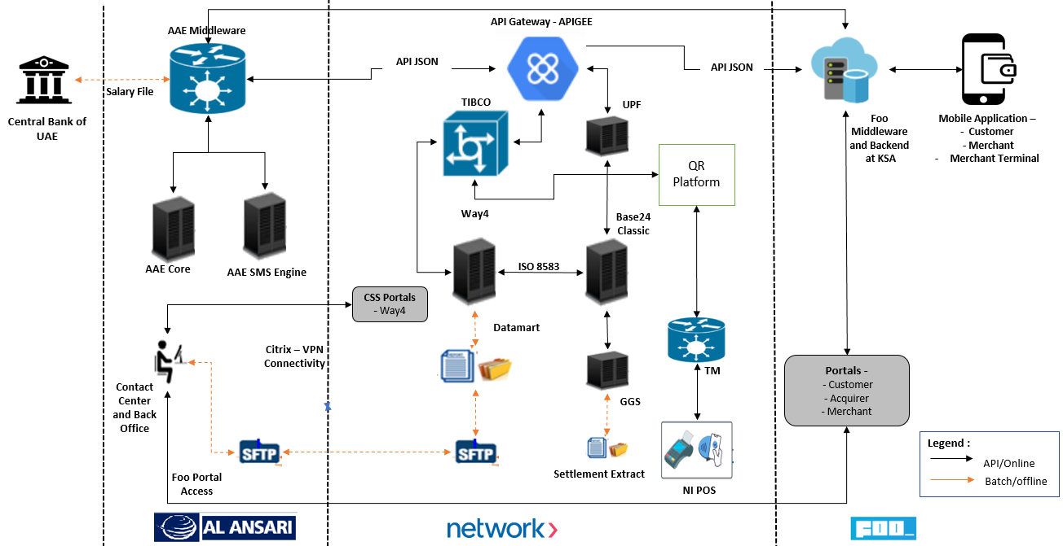

## **Transaction Process**

* Al Ansari digital pay will support various payment services like below –
  + Wallet to Wallet Transfer (P to P)
  + Wallet to Merchant (P to M applicable for NI and Non-NI merchant)
  + Cash-in and Cash-out
  + Balance inquiry
  + Account to Account transfer (WPS Payroll to SVA Wallet)
  + Bill payment
  + Remittance
  + Request to Pay
* Al Ansari Digital Pay will support biometric or PIN based authentication.
* The velocity check parameters will be setup in NI CMS to control the transaction approval and limits.
* The Open to Buy will be updated in NI CMS after each successful transaction.

### **Stand In Process**

* To Support maximum system Availability, NI Switch will be updated with the latest balances on the daily basis and for each Debit and Credit initiated towards customer wallet.
* In case HOST (i.e. WAY4) is offline for transaction authorization, transactions will be authorized by Base4 system. Once the HOST is online, the balance update advices will be sent to WAY4 for updating the latest balances based on transaction approved by switch system.

### **Transaction mapping**

* + Below is the mapping for transaction codes in NI CMS for each type of transaction supported by the wallet -

|  |  |
| --- | --- |
| **Transaction Type** | **NI CMS Transaction Mapping** |
| Wallet Top-up Cash-In – Credit to Wallet | TBD |
| Wallet Top-up Cash-out Debit to Wallet | TRANS_DT_CASH |
| Wallet to Wallet Debit from Senders Wallet | TRANS_DT_PAYMENT_TRANSF |
| Wallet to Wallet Credit to Receivers Wallet | TBD |
| Wallet to Merchant Debit from Senders Wallet | Retail |
| Wallet to Merchant Credit to Non-NI Merchant | TBD |
| Remittance | TBD |
| Bill Payment | Utility bill Payment |
| Wallet to NI Merchant Wallet | TBD |

* + NI CMS transaction mapping will be part of transaction extract for Al Ansari to segregate the type of transaction for any type of settlement or analytics.
  + All transaction are reported in the an transaction dump extract. The transaction dump layout is present in Appendix section.

### **Customer communication**

* + After every transaction, customer will get notification on customer mobile application for respective services success or failure.
  + Additionally customer will be notified with Email and SMS alert for transaction outcome. For SMS and Email notification the required configuration or integration will be considered between the Al Ansari Digital pay.

|  |  |
| --- | --- |
| *Important notes* | * *Any service fee for SMS or Email notification will be managed and handled by Al Ansari.* * *NI and Foo will not integrate with any SMS or Email service provided for customer notification. Existing Al Ansari SMS or email services will be used for this purpose.* |

## **Wallet services**

### **Wallet Inquiry**

* The wallet inquiry service will initiated from Al Ansari Digital Pay , whenever customer login or opens application.
* The Wallet inquiry service will include wallet details including balance available in the wallet and other wallet details.
* Al Ansari digital pay will be integrated with below API to fetch wallet details from NI CMS –

<https://developer.network.ae/docs/read/card_services/version_2/Card_Details>

* WPS customers balance will be fetched from Al Ansari Core by integrating API with AAE middleware. Below is the proposed flow and process to fetch balance from NI CMS and AAE Core –

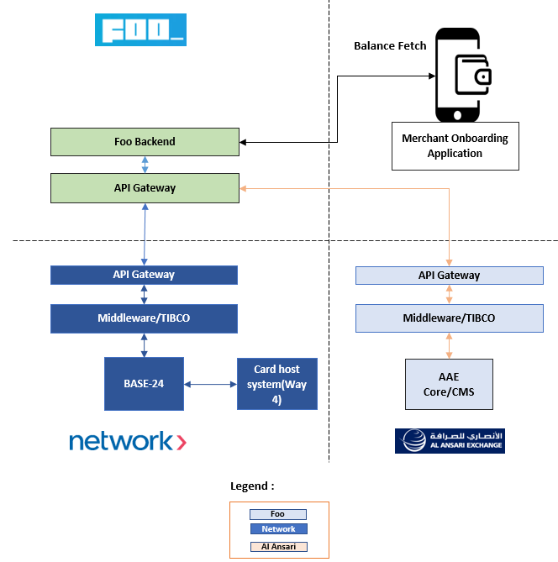

* Customer Login to Al Ansari Digital Pay application
* Application identifies customer has two wallets i.e. Wallet managed at NI and WPS Payroll Wallet.
* Foo Initiates the request with NI for fetching balance from NI CMS. NI CMS returns the balance for SVA wallet hosted for customer.
* Foo initiates request with AAE to fetch balance from AAE Core/CMS. AAE Core returns the balance associated to WPS Payroll Wallet
* Foo displays the balances for both the systems.

### **Account to Account Transfer –** (WPS Payroll to SVA wallet Transfer only)

* Fund transfer from WPS Payroll to SVA Wallet will be initiated by Application upon customer confirmation. The fund transaction request is initiated from Al Ansari Digital Pay when customer is using other services from the main SVA wallet and insufficient fund available in main Wallet.
* The service will debit funds from Payroll card from AAE core and credits SVA wallet supported in NI CMS.

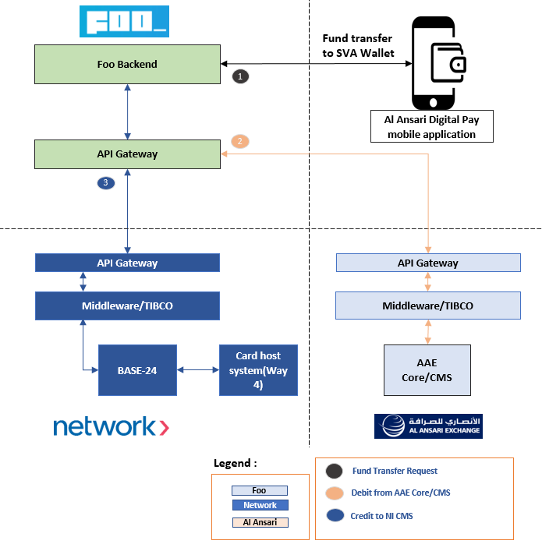

**Step 1 -**

* Customer Login to Al Ansari Digital Pay application
* Customer selects WPS wallet
* Option will be displayed “Account to Account Transfer” i.e. transfer funds from WPS Wallet to Main Wallet
* Customer will provide the amount to be transferred from WPS Wallet to Main Wallet

**Step 2 -**

* Once confirmed by customer to proceed with transfer, Foo backend Initiates debit request with AAE Middleware.
* AAE Middleware sends feedback to Foo API Gateway after balance and verification in AAE CMS.

**Step 3 -**

* Foo backend then initiates the credit request for Main Wallet SVA hosted in NI system.
* Once credit posted successfully, NI sends feedback to Foo Backend
* Front end will display message for fund transfer confirmation.

|  |  |
| --- | --- |
| *Important notes* | * *This service will be applicable only for fund transfer from WPS Payroll card to SVA Wallet.* |

### **Wallet Top-up Via bulk Payment or top-up file**

* Al Ansari can use bulk interface option to top-up balances on the SVA accounts.
* The interface file will have standard format in which the data is expected to be provided from Al Ansari.
* The file will be placed by Al Ansari on the agreed SFTP location, from where NI will pick up the file for processing and updating the balance after file processing.
* Wallet ID to be passed in bulk file for posting payment onto the customer wallet account.
* Once the file is processed at NI, the response file will be generated from NI that provides details about payment update response. Al Ansari can use this response file for initiating notifications to customers about top-up.
* NI does not have any restriction on the number of files to be processed in a day.

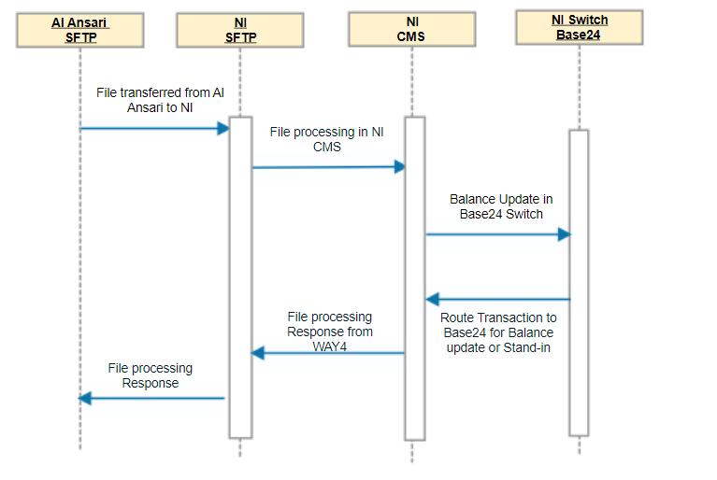

* Please refer to “Financial posting service” file layout is attached in Appendix Section.

|  |  |
| --- | --- |
| *Important notes* | * *The notification to customers for top-up will be managed and handled by Al Ansari. The bulk Financial response report can be used to initiate customer notification.* |

### **Wallet Top-up via Cash-in**

* Al Ansari will provide an option to fund Wallets by accepting cash at Al Ansari Exchange house or authorized partners.
* Al Ansari will perform customer validation and verification before initiating the Wallet top-up request.
* NI will expose an transaction posting API for initiating top-up to customers wallet account. Al Ansari can integrate the API at required channels like CRM to initiate request with NI.
* The balance in the customer application
* Below API specification for reference to perform both cash-in/Cash-out functions from Al Ansari -

<https://developer.network.ae/docs/read/card_services/version_2/Card_Transaction>

* Al Ansari to confirm what details to be stored for transaction for tracking purpose.

|  |
| --- |
| Figure - Cash-In at Al Ansari Exchange |

|  |  |
| --- | --- |
| *Important notes* | * *Al Ansari to initiate request with Wallet ID for initiating Cash-in or Cash-out request.* * *API can be used for both Cash-in and Cash-out functions.* |

### **Peer to Peer (P to P) Fund transfer**

* The Peer to Peer will be essentially Wallet to Wallet fund transfer between the sender and receiver wallet accounts.
* Sender will have three options on mobile application to select the mode of fund transfer
  + Via QR Scanning of the Receiver/Beneficiary
  + Via selecting the mobile number from the contacts list on the mobile device
  + Via mobile number search to identify customer

#### Via QR Scanning of Receiver/Beneficiary

* Sender opens the mobile application and navigates to fund transfer option for making a payment to Receiver/Beneficiary.
* Receiver/Beneficiary logins to customer application and selects option to show QR. The QR scan should provide a unique identifier of Receiver/Beneficiary in response.
* Sender scans the QR presented by Receiver/Beneficiary and on the next screen customer provides the amount to be transferred.
* Al Ansari Digital Pay will orchestrate the below –
  + First debit the amount from Sender’s wallet
  + Second to credit the amount to receiver’s wallet
* Below API can be used for both debit and credit request for P to P – <https://developer.network.ae/docs/read/card_services/version_2/Card_Transaction>

|  |  |
| --- | --- |
| Figure – P to P via QR Transaction Authorization flow | |
| *Important notes* | * *Sender and Receiver/Beneficiary may have application hosted onto different application store and this will be supported.* |

#### Via mobile number search of / contacts list of Receiver/Beneficiary

* Sender opens the mobile application and navigates to fund transfer option for making a payment to Receiver/Beneficiary.
* Sender provides mobile number (Ex. An example display to show format in which mobile number to be entered) or selects the mobile number from the contacts list on the mobile device.
* Sender validates and verifies receiver/beneficiary details for making a payment and confirms to proceed with the request.
* Al Ansari Digital Pay will orchestrate the below –
  + First debit the amount from Sender’s wallet
  + Second to credit the amount to receiver’s wallet
* Below API can be used for both debit and credit request for P to P – <https://developer.network.ae/docs/read/card_services/version_2/Card_Transaction>

|  |  |
| --- | --- |
| Figure - Fund Transfer via mobile number | |
| *Important notes* |  |

### **Peer to Non-Ni Merchant (QR Based)**

**Purchase:**

* Customer initiates transaction from application for payment to a non-NI merchant.
* Merchant opens the merchant/terminal application to present QR to customer for payment acceptance.
* Customer scans QR and confirm payment and confirms transaction by authentication process.
* Al Ansari Digital Pay will orchestrate the below –
  + First to debit the amount from Sender’s wallet
  + Second to credit the amount to receiver’s wallet, basically the merchant SVA
* Below API can be used for both debit and credit request for P to M (non-NI Merchant) – <https://developer.network.ae/docs/read/card_services/version_2/Card_Transaction>

|  |  |  |
| --- | --- | --- |
| Figure - Non-NI merchant Payment acceptance | | |
| *Important notes* | * *As there can be multiple terminal associated to single merchant SVA wallet, system will not support concurrent transaction acceptance at an same very time.*   *Ex. If 2 customer are trying to make payment towards same merchant at a same very HH:MM:SS then one transaction may get rejected.*   * *However transactions can be accepted to same merchant from different M-POS (via terminal application) or via Static QR placed by merchant.* * *Al Ansari to let us know if any big merchants are planned to be introduced in the non-NI merchant proposition.* |

**Refund:**

* The non-NI merchant refunds will be handled outside the system, as non-NI merchant mobile application does not have option to void or refund transaction.
* Al Ansari to confirm on this process.

### **Remittance**

**Purchase:**

* The application will provide an option to perform the international remittance via Wallet.
* The application will be integrated with Remittance channel of Al Ansari via API by getting necessary details.

Steps 1 – Customer selects a remittance option and selects the country to which the remittance to be performed.

Step 2 – Once the country is selected there will be request initiated from Application to Al Ansari to get the required details to complete the remittance.

Step 3 – Upon providing remittance details the request will be initiated with AAE Middleware to perform remittance.

Step 4 – AAE will provide the debit amount to be deducted from Wallet. The debit amount will include all fees that is application for remittance and VAT if applicable.

Step 5 – System will debit Wallet and inform AAE about the debit completion.

Step 6 – AAE Then will complete remittance via their existing channels.

Step 7 – Once remittance is completed AAE send response to Application.

Step 8 – Customer gets notification of remittance completion.

|  |  |  |
| --- | --- | --- |
| Figure - International remittance | | |
| *Important notes* | * *The debit amount received from AAE to include all Fees applicable for remittance including remittance fee + VAT if applicable or any other fees.* |

**Refund:**

* In cases when remittance debit was successfully completed and SVA wallet is already deducted, but actual international remittance was not successful and SVA wallet to be credit back, in such refund cases. Al Ansari can use below API to credit wallet, however the transaction will be treated as top-up or credit to wallet - <https://developer.network.ae/docs/read/card_services/version_2/Card_Transaction>

### **Bill Payment**

**Purchase:**

* Customer will view the bill option in mobile application.
* The application will be integrated with bill payment aggregator of Al Ansari via API by getting necessary details.

Steps 1 – Customer selects a bill payment option and selects the biller to which the payment to be performed.

Step 2 – Once the biller is selected there will be a request initiated from Application to Al Ansari to get the required details to complete the bill payment.

Step 3 – Upon providing details the request will be initiated with AAE Middleware to perform bill payment transaction.

Step 4 – AAE will provide the debit amount to be deducted from Wallet. The debit amount will include all fees that is application for remittance and VAT if applicable.

Step 5 – System will debit Wallet and inform AAE about the debit completion.

Step 6 – AAE Then will complete bill payment via their existing channels.

Step 7 – Once bill payment is completed AAE send response to Application.

Step 8 – Customer gets notification of bill payment completion.

* NI CMS will show bill payment as an transaction, any additional details related to bill payment will be captured as part of additional transaction data.

|  |  |  |
| --- | --- | --- |
| Figure - Bill Payment | | |
| *Important notes* | * *The debit amount received from AAE to include all Fees applicable for bill payment including VAT if applicable or any other fees.* |

**Refund:**

* There are no refund scenarios envisaged for Bill Payments, as the bill payment are realized to billers immediately and SVA wallet will be debited after biller payment realization.
* AL Ansari to check and confirm.

### **P to M – N-Genius POS or N-Genius Ecomm (In-Progress at NI)**

* The Wallet payment will be accepted at NI N-Genius POS and Ecomm merchants via QR.
* The merchant POS and Ecomm will be enhanced to provide an option to accept payment via Al Ansari digital pay application.
* The mode of payment acceptance at NI POS or Ecomm will be via QR presentation, where the QR will be scanned by the customer using the Al Ansari Digital Pay application, and the payment will be initiated by the customer to the merchant.
* Al Ansari Digital Pay will orchestrate the below –
  + Debit the amount from Senders wallet
* Below API can be used for both debit and credit request for P to M – <https://developer.network.ae/docs/read/card_services/version_2/Card_Transaction>
* The credit to NI merchant will be part of the settlement and still under discussion.

|  |  |
| --- | --- |
| Figure - Payments at NI merchant | |
| *Important notes* | * *Only N-Genius POS and Ecomm will support payment acceptance via Al Ansari Digital Pay* |

## **Transaction Posting/Clearing**

* Single message systems (SMS) i.e. the transaction gets posted on CMS based on the authorization message.
* All the transaction supported by wallet will be SMS and does not require clearing or settlement for transaction posting to an Wallet.

## **Wallet Limiters**

* The limits to be available at SVA Wallet level to control transaction approval. The limiters will be validated in NI CMS as part of transaction validation.
* These limits are to be setup in NI CMS at product level -
  + Transaction Limit – the maximum allowed limit per transaction at an Wallet SVA level.
  + Daily Limit – Daily accumulated limit at an Wallet SVA level.
  + Monthly Limit – Monthly accumulated limit at an Wallet SVA level.
  + Yearly Limit - Yearly accumulated limit at an Wallet SVA level.
* The limiters to be provided for controlling transactions initiated from an wallet SVA and to be available at the product level.
* The limiters will be setup in NI to control below -
  + Maximum allowed limit for a type of transaction – The maximum allowed limit for per transaction I.e. respective transaction should not be allowed to exceed more than maximum limit set.
  + Daily Limit and count – Daily limit and count to be accumulated for each type of transaction and respective counter, beyond limit threshold transaction should will be declined.
  + Monthly Limit and count – Monthly limit and count to be accumulated for each type of transaction and respective counter, beyond limit threshold transaction should will be declined. This will be monthly accumulation.
* Below types of limiters available in system to control respective services -
  + Payment via Cash - Can be used for Top-up Cash-In
  + Cash withdrawal – Can be used for Cash Out
  + Retail Purchase – Can be used for all other services (P to P, P to M, Remittance and bill payment)
* The rejection code and reason will be provided in response from NI CMS, so that front end can display appropriate decline message to user.

|  |  |
| --- | --- |
| *Important notes* | * *Nationality and customer specific limiters cannot be provided as system does not approve or segregate transactions based on nationality.* |

## **Transaction Details**

* Al Ansari Digital Pay will have option to view transaction history and details.
* Customer will be able to select the period for which the transactions to be viewed and the request will be initiated from Al Ansari Digital Pay to NI CMS for fetching transaction details.
* Below API will be integrated with Al Ansari Digital Pay for fetching the transaction details - <https://developer.network.ae/docs/read/card_services/version_2/Transaction_Details>
* The transaction will include all details like, amount, currency, merchant name, Merchant category code, transaction description etc. Please refer above mentioned API response to get the list of all fields that are returned in response from NI CMS for each individual transaction.

## **Statement Generation**

* NI CMS will setup an standard billing cycle for each wallet so that all transaction performed in a specific period can be displayed to customer as an monthly statement.
* NI CMS will generate an text based monthly statement file and will be shared with Al Ansari to process and generate the PDF statement. The statement file will include email address of the customer which can be used to send PDF statement to customers registered e-mail address.
* The statement can also be viewed in application using below API, where the statement period can be provided as input request along with wallet details to fetch statement transactions –

<https://developer.network.ae/docs/read/card_services/version_2/Transaction_Details>

## **AML and Fraud Indicators**

* In case the AML and Fraud indicators are placed on an wallet or customer account, the respective services will not be approved until the restrictions are in-place.
* The AML and Fraud indicators will be validated for each transaction. The rejection due to such restriction will be responded with appropriate reject reason code and reject reason.

## **Fees and Service**

* Al Ansari to confirm if any Fees requirement. Ex. Any lifecycle fee or charges.
* As per current scope, NI will not setup any fees for wallet services or usage. However for wallet services fees can be setup as part of configuration.

## **Operational service**

### **Chargeback & dispute management**

* Chargeback and dispute process in-progress

### **Settlement**

* Below flow shows the P to P settlement process where all the transaction performed in a day will be provided.

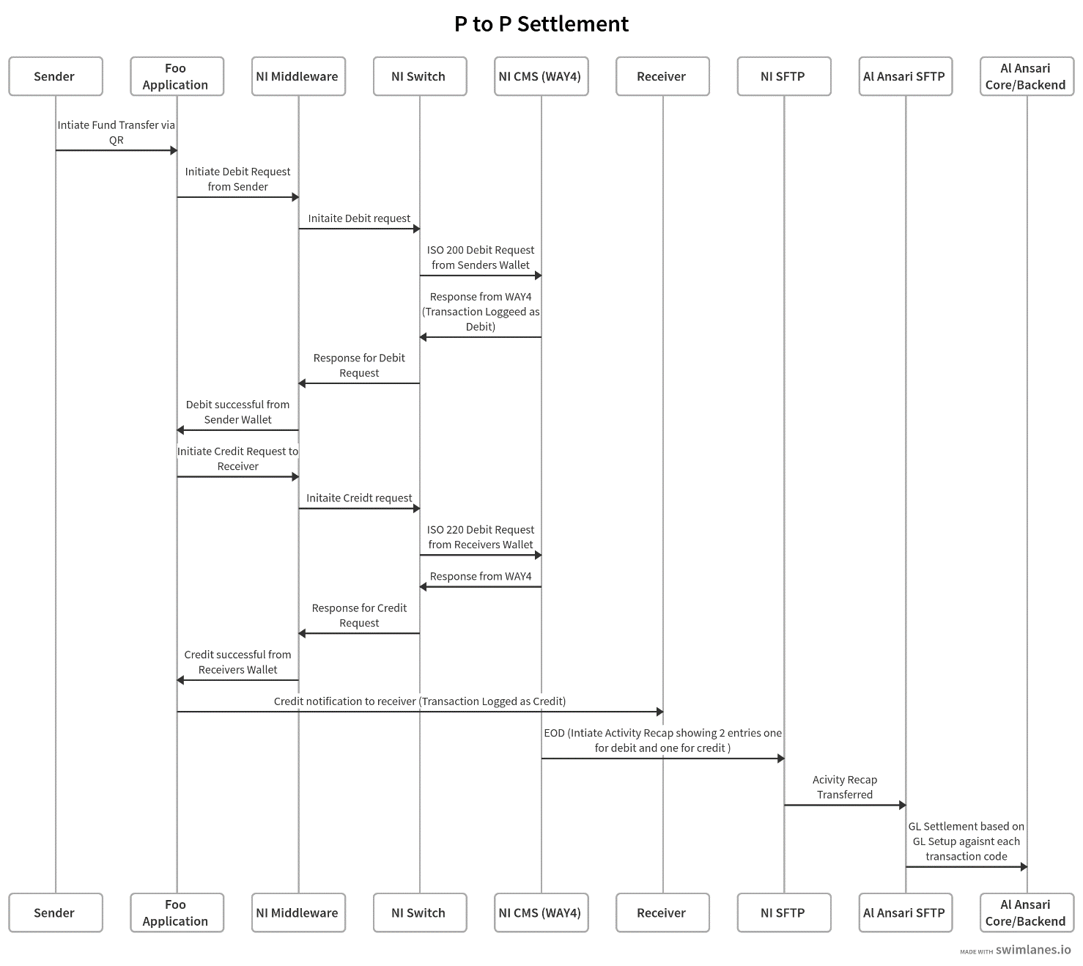

# Key Assumptions/Solution Considerations

* Client number will be generated by Al Ansari, while Account number and Wallet number will be generated by NI.
* For API integration between Al Ansari and NI, Al Ansari will adopt to NI API specs.
* Customer (Client/Account/Wallet) onboarding will be done via NI standard APIs.
* Al Ansari will adapt to NI’s standard API Specs for inbound APIs to NI. Al Ansari will integrate with NI via NI API gateway to consume inbound APIs.
* Al Ansari will adapt to NI’s standard batch interface and report specs for incoming and outgoing batch interface integrations. NI will exchange batch interfaces and reports to/from Al Ansari via SFTP.
* SMS delivery to end customer will be managed by Al Ansari.
* Al Ansari users will have “View only” access to CMS screens. All financial or non-financial maintenance will be done via API or batch interface channels.
* UAT will be done by Al Ansari. NI and FOO will provide UAT Support

# Out of Scope

* Any functionalities/customization not mentioned in solution overview
* Any operational services not mentioned in Scope/Assumption section
* Multi-currency product, corporate product is not part of the scope
* Integration with third parties for bill payment, remittance etc. except Al Ansari middleware will not be in scope of NI.
* KYC, AML, Sanction screening will not be performed by NI
* Statement printing/distribution will not be in scope
* Card on file data (Storing external card information on NI CMS) is not in scope.

# Queries/Outstanding points

* UAT will be done by Al Ansari. NI will provide UAT Support

# Appendix

* Incoming and Outgoing interfaces



* Reports

